Figure 1: Undeformed 2D Plate Structure
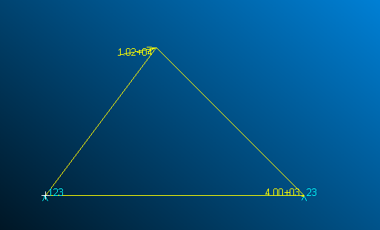

Figure 2: Deformed Structures for each Thickness Case
Thickness of Plate (in) | Deformed Structure
0.015 | 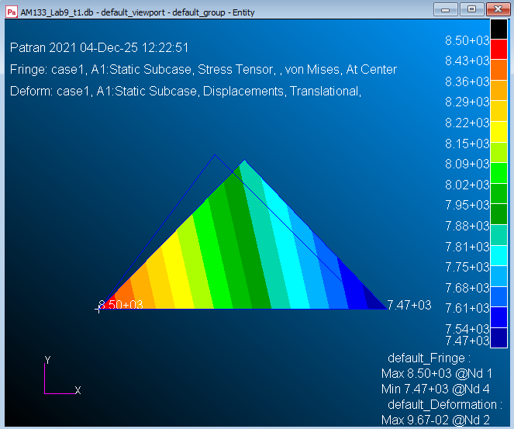
0.03 | 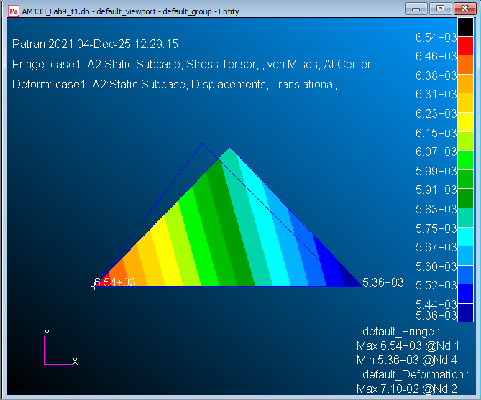
0.06 | 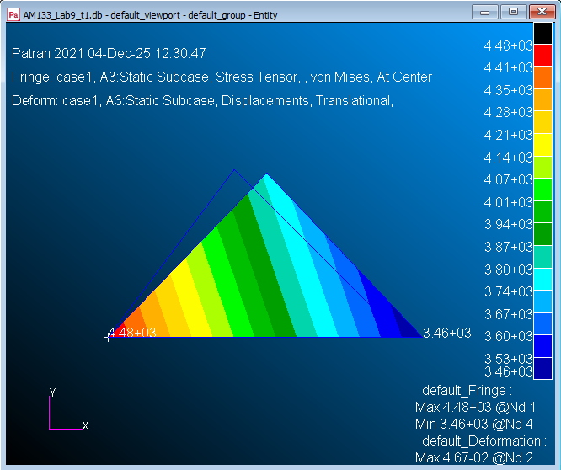

Table 1: Nodal Displacements and Element Stresses for Each Thickness Case
Thickness of Plate (in) | Node | Displacements (in) | El. | Element Stresses (psi)
0.015 | 1 | [0.0, 0.0, 0.0] | 1-2 | 8.110274E+03 [T]
 | 2 | [5.677192E-02, 0.0, 0.0] | 2-3 | -6.834869E+03 [C]
 | 3 | [9.539969E-02, -1.605118E-02, 0.0] | 3-1 | 8.879773E+03 [T]
0.03 | 1 | [0.0, 0.0, 0.0] | 1-2 | 6.127460E+03 [T]
 | 2 | [4.289222E-02, 0.0, 0.0] | 2-3 | -4.589774E+03 [C]
 | 3 | [7.034290E-02, -9.267515E-03, 0.0] | 3-1 | 6.958346E+03 [T]
0.06 | 1 | [0.0, 0.0, 0.0] | 1-2 | 4.159115E+03 [T]
 | 2 | [2.911381E-02, 0.0, 0.0] | 2-3 | -2.769610E+03 [C]
 | 3 | [4.644915E-02, -4.821534E-03, 0.0] | 3-1 | 4.802453E+03 [T]

